ESCAP/WMO Typhoon Committee  ______________  FORTY-FIRST SESSION  CHIANG MAI, THAILAND  19 – 24 JANUARY 2009 |  | WRD/TC.41/5.7 rev.1  ______  AGENDA ITEM 5  Original: ENGLISH

TYPHOON COMMITTEE SECRETARIAT
ANNUAL REPORT 2008

(Submitted by Typhoon Committee Secretariat)

________________________________________________________

Summary and Purpose of Document:

This document reviews the principal activities of Typhoon Committee Secretariat during 2008.
_________________________________________________________

Action Proposed

The Committee is invited to:

Take note of document Typhoon Committee Secretariat Annual Report 2008 and respective Annexes:

Annex 1- “Allotment/Expenditure for Typhoon Committee Trust Fund (TCTF)- Estimated Balance of TCTF for the period 1 January to 31December 2008”
Annex 2 – Activities supported by Macao Foundation

Annex 3 - SUMMARY REPORT: Integrated Workshop on Coping with Climate Change in the Typhoon Committee Area

TYPHOON COMMITTEE SECRETARIAT
ANNUAL REPORT 2008

- Introduction

The Typhoon Committee Secretariat (TCS) is the executive arm of the TC and its functions are described in the document “Terms of Reference of the Typhoon Committee Secretariat”.
The TCS was established in 1968 as the ECAFE/WMO Joint Unit on Typhoons and was initially located in Bangkok, Thailand. In response to an invitation from the Philippines, it was transferred to Manila in 1971 and was renamed Typhoon Committee Secretariat. Following a preliminary proposal of the Interim Working Group (IWG) on the Regional Cooperative Programme Implementation Plan (RCPIP) to the 36th Session of the Typhoon Committee, the Working Group on the Review of Operations and Structure of the TC (ROSTY) recommended the rotational hosting of the Secretariat. This recommendation was adopted at the 37th Session of the TC, held in Shanghai in November 2004, and was followed by decision of the 38th Session, held in Hanoi in November 2005. Based upon this decision the TCS was transferred in 2007 to Macao, China for a minimum of 4 years with possibility of extension of another four years.

- Composition of TCS

As at 31 December 2008 the composition of TCS is as follows:

Mr. Olavo Rasquinho - Secretary
Mr. Leong Kai Hong (Derek) – Meteorologist, seconded Macao, China
Mr. Liu Jinping - Hydrologist, seconded by People’s Republic of China
Ms. Denise Lau – Senior Administrative Secretary
Ms. Kou Meng Kit (Lisa) - Senior Finance Clerk

- Song and emblem/symbol contest

  - Song contest

The Typhoon Committee, in its 40th Session, held in Macao, China, 21-26 November 2007, decided to develop a song for the 41st session (Paragraph 65, 12th Bullet – Report of the Fortieth Session). Following this decision, TCS send a Circular Letter to all Directors and focal points of the three components, inviting for proposing a song for TC. Three Members have proposed five entries:

Hong Kong (Hong Kong Observatory)

Title - Typhoon! Typhoon!
Lyrics - C Y Lam (Director of Hong Kong Observatory
Music - F. Lam

USA (Central Pacific Hurricane Center)

Eye of the Storm
Lyrics: 5th Grade of a private school in Honolulu
Music: Linda Weyman

"Cyclones, Typhoons, Hurricanes"
Author: Tim Ross (USA National Weather Service)

Viet Nam (National Hydro-Meteorological Service)

"Feelings of a Weather Forecaster" (file name Vietnam_1.rar)
Music: Vuong Sinh Lam
Lyrics: Vuong Sinh Lam and Nguyen Dai Khanh

“Romantic Song of Hydro-meteorological Observer"
Music and lyrics: Vuong Sinh Lam

Selected song: “Typhoon! Typhoon!” proposed by Hong Kong.

  - Emblem/Symbol Contest

The Typhoon Committee, in its 40th Session, held in Macao, China, 21-26 November 2007, decided to create an emblem/symbol for the TC as one of the activities to commemorate its 40th anniversary and noted that it would be a Member-wide submission with the TCS as the entity responsible for collecting Members’ inputs and submitting the entries to the AWG (Paragraph 65, 11th Bullet - Report of the Fortieth Session of the Typhoon Committee).

Contest in Macao and Proposal from Hong Kong

TCS, with the support of the Macao Meteorological and Geophysical Services (SMG), promoted a contest in Macao, whose rules were established by TCS under the supervision of the TC Advisory Working Group. These rules were presented to the media at the commemorations of the “World Meteorological Day”, at SMG headquarters. On 9th May 2008 a jury met at the headquarters of SMG to evaluate the 42 design proposals submitted by 29 candidates. The jury was composed of one representative of SMG, one of TCS, one designer from the Cultural Institute of Macao, one lecturer of School of Arts from Macao Polytechnic Institute, and one architect. The winners of the Typhoon Committee emblem/symbol contest, in Macao, selected by the Jury were: 1st prize Chan Sau In; 2nd prize Filipa Botelho; 3rd prize Ricky, Fan Sai Fong. Other than the three winners selected by the Jury, it was also decided to present a complementary award (honourable certification) to Ana Botelho, so as to acknowledge her high standard design proposal.

Selection of the Emblem/Symbol by Advisory Working Group

Hong Kong has also submitted an entry designed by Ms Mirinna Kam-chu Chan. Both proposals, the first prize of Macao contest and the entry from Hong Kong, were submitted to the Advisory Working Group of the Typhoon Committee that selected the proposal from Macao, China.
The expenses related to the three prizes were supported by Macao Foundation.

Participation of TCS in international activities

Since the 40th Session of TC, held in Macao, China, 21-26 November 2007, TCS staff was invited to participate in the following events/actions:

  - International Flood Network (IFNet) 4th General Meeting, Beppu City, Japan, 1 December 2007

The TC Secretary was invited by the Infrastructure Development Institute of Japan (IDI), through the International Flood Network (IFNet) Secretariat, to address a presentation in the 4th General meeting of IFNet, which was held concurrently with the Asia Pacific Water Summit, at Beppu City, Japan, on December 1, 2007. The presentation focused the activities of Typhoon Committee, especially those related to hydro-meteorological hazards and disasters. The purpose of this meeting was to contribute for report on the activities of IFNet after the 4th World Water Forum (México 2006), for the activity plan-2008, and for the revision of the charter for making activities under IFNet more effective to contribute to flood disaster reduction. Many of the addresses and presentations expressed the concern in promoting good practices in risk management of water-related disasters, especially floods. The IFNet has as objective to facilitate international cooperation in flood management to reduce the loss of life and damage caused by floods, to promote policies and practices which can break the circle of poverty and environmental degradation and lead to a safe and sustainable future.

  - First Asia-Pacific Water Summit, Beppu, Japan, 3-4 December 2007

The TC Secretary was invited by Dr. Yoshiro Mori, Chair of Steering Committee of the 1st Asia-Pacific Water Summit (APWS) and President of the Asia-Pacific Water Forum (APWF), to attend this important Summit.
The 1st APWS convened political leaders, namely heads of Governments of the Asia-Pacific region, in 3 and 4 December 2007 in Beppu City, Oita Prefecture in Japan. The Summit offered a platform to launch initiatives and achieve commitments related to water challenges. The priority themes consisted of: (A) Water Financing, (B) Disaster Management and (C) Water for Development and Ecosystem. The Summit covered, among other subjects, matters related to climate change, water-related disaster management, sanitation, water for development and ecosystems, developing knowledge and lessons.
An important message was issued (Message from Beppu) which was unanimously endorsed by the participants, namely ten Heads of State and Government, 31 Ministers, and representatives from 36 Asia-Pacific countries and regions. The APWS was convened by APWF, an independent, not-for-profit network of the water stakeholders in Asia-Pacific Region. The Secretariat of the 1st APWS edited recently “The Proceedings of 1st Asia Pacific Water Summit” (more information in http://www.worldscibooks.com).

  - Fifth Disaster Management Practitioners’ Workshop for South East Asia - Phnom Penh, Cambodia, 2-4 APRIL 2008

UNESCAP and the Asia Disaster Preparedness Center (ADPC), through its Partnerships for Disaster Reduction South East Asia (PDRSEA) Project, realized the 5th Disaster Management Practitioners’ Workshop which was held in Phnom Penh, Cambodia, from 02 to 04 April 2008. The Secretary of TC was invited to address the presentation “Sustaining Partnerships among Warning Agencies in South East Asia - the role of the ESCAP/WMO Typhoon Committee”, in which he had the opportunity to inform the participants on the vision and mission of TC and how the disaster management practitioners can profit from the experience of TC in the field of typhoon related disasters. In his presentation the Secretary emphasized that, notwithstanding the TC is an intergovernmental body created for minimizing the loss of life and material damage caused by typhoon-related disasters, the fact of dealing with three of the most important components involved in natural disasters has permitted the coordination of activities in the area of natural hazards frequently not directly connected to tropical cyclones, such as floods, flash floods, landslides or debris flows. He also stressed that in each Member of the Typhoon Committee there are focal points and that the community based warning agencies might contact them in order to be oriented on how to access to the achievements related to disaster management. The participants were informed that the list of the focal points can be accessed at the TC Webpage.
This workshop provided a good opportunity for personnel involved in disaster management to gather in order to share experiences and lessons, identify gaps and promote strategies to disaster risk reduction on a regional basis.

  - Third Typhoon Committee Working Group Meeting on DPP on Typhoon Committee Disaster Information System and Future Activities" - Seoul, Republic of Korea, 10-11 April 2008.

The TC Secretary and the Senior Administrative Secretary of TC, Ms Denise Lau, were invited by the Korean National Emergency Management Agency (NEMA) and National Institute for Disaster Prevention (NIDP), to attend the “3rd TC Working Group Meeting on Disaster Prevention and Preparedness on Typhoon Committee Disaster Information System (TCDIS) and Future Activities", which was held Seoul, Korea, on April 10 and 11.
The objectives of the (TCDIS) were pointed out: to establish a disaster data sharing system among the TC Members and in the region and a trusted source of disaster information for Members, decision makers and public in general. Some relevant opinions, suggestions and recommendations related to TCDIS were expressed during the discussions.
Following the recommendation of TC taken in the TC 40th Session related to an expert mission to some Members, it was decided to realize the mission in May 2008.
The representative of UNESCAP considered the TCDIS will surely be one of the major accomplishments of the DPP component of TC.

  - 64th Session of Economic And Social Commission For Asia and The Pacific (ESCAP)- Bangkok, Thailand, 24-30 April 2008

The Secretary of TC was invited to attend the 64th Session of the Economic and Social Commission for Asia and the Pacific, UNESCAP, which was held in Bangkok, from 24 to 30 April 2008. He participated in the Senior Officials’ Segment (24-26 April) and presented a summary of the report on the activities of TC in 2007. TCS is pleased to transcribe from the ESCAP ANNUAL REPORT (24 May 2007-30 April 2008) the following extract (Agenda item 3 - Management issues, Sub-item (i) - Reports of regional intergovernmental bodies):

Report of the Typhoon Committee

The Commission had before it the report of the Typhoon Committee, transmitted for information through a note by the Secretariat (E/ESCAP/64/INF/3 and Corr.1).
The Commission was informed of the activities of the Typhoon Committee that had been implemented in 2007, following the adoption of its strategic plan, 2007-2011, in 2006. It noted important achievements, major issues and future directions related to three major areas of work of the Typhoon Committee: its meteorological component, hydrological component and disaster prevention and preparedness component. The report of the Typhoon Committee described the progress made in the implementation of the strategic plan, in particular the integration of the three key components in order to more effectively contribute to socio-economic development in the context of the three key areas. The report also described initiatives such as the development of the organization’s disaster information system as a strategic instrument for supporting its efforts to become a leading sub regional organization dealing with cyclone-related disasters.
One delegation expressed its appreciation for the new approach that had been adopted by the Typhoon Committee to assist its members in better managing typhoon-related disasters. It called on the donor community and international organizations to increase their support for the Typhoon Committee so that it could realize its goal of becoming the world’s best sub-regional organization involved in the management of cyclone-related disasters.
The Commission took note of the new institutional setting of the secretariat of the Typhoon Committee, which had been moved to Macao, China, in February 2007, and the strong support afforded to the Committee by the Government of China and the Macao Special Administrative Region. The Commission noted that Thailand would host the forty-first session of the Typhoon Committee in the latter part of 2008 to commemorate the fortieth anniversary of its establishment by the Economic Commission for Asia and the Far East in Bangkok in 1968.
The representative of the World Meteorological Organization (WMO) informed the Commission that, at the fifteenth World Meteorological Congress, which had been held in Geneva in May 2007, sincere appreciation had been expressed to two regional intergovernmental bodies: the WMO/ESCAP Panel on Tropical Cyclones and the Typhoon Committee, for the excellent work that was being carried out to promote the strengthening of the disaster preparedness, warning and prevention measures related to tropical cyclones, storm surges and floods in the region. The representative of WMO indicated that the organization would continue making every effort to fully support the work of those bodies.

  - Fifth Annual Meeting of the Asia Oceania Geosciences Society (AOGS), Busan, Korea, 16-20 June 2008

Mr. Jinping Liu, hydrologist of the Typhoon Committee Secretariat, whose participation was funded by the Korea Water Forum, gave a presentation on “Experiences on Water-Related Disaster Management in China” at the Session “Assessment of Socio-economic Impacts of Water-related Disasters”, chaired by Vice- chairman of TC WGH Dr. I1-pyo Hong of the Korea Institute of Construction Technology (KICT) and Dr. Le-Huu Ti of UNESCAP. Five speakers from Typhoon Committee Members gave presentations focused on the TC activities. Dr. Le-Huu Ti made the presentation “Facilitating Rapid Assessment of Socio-economic Impacts of Typhoon Committee Area”. Dr. Hong gave the presentation on “Assessment of Socio-economic Impacts of Water-related Disasters for better Infrastructure Development in Typhoon Committee Area”. On behalf of Dr. Waon-Ho Yi, the Chairman of TC WGDPP, Dr. Jitae Kim gave the presentation “Strategies for More Effective Regional Cooperation to Mitigate Socio-economic Impacts of Typhoon-related Disasters”. Dr. Kim also introduced the “Experiences in Automatic Assessment of Socio-economic Impacts of Water-related Disasters in Republic of Korea”, in which he stressed the importance of the ongoing TC project “Typhoon Committee Disaster Information System” (TCDIS), lead by Republic of Korea, All presentations, especially the introduction to TCDIS, attracted the participants.
This participation of Mr. Jinping Liu in the AOGS 2008, as Hydrologist of TC, contributed for promoting the visibility of TC and for making known its mission and activities on typhoon-related disaster prevention and preparedness.

- Integrated Workshop on Coping with Climate Change in TC Area, Beijing, 22-26 September 2008

The “Integrated Workshop on Coping with Climate Change” was held in Beijing, China, 21-26 September 2008. It was organized by the Ministry of Water Resources of China, Bureau of Hydrology, and the China Meteorological Administration in cooperation with UNESCAP, TCS, WMO, the Ministry of Construction and Transportation of Republic of Korea (MOCT), Korea Institute of Construction Technology (KICT), Korea Water Corporation (K-Water), together with Ministry of Land, Infrastructure and Transport of Japan (MLIT), Infrastructure Development Institute – Japan (IDI) and the National Institute for Land and Infrastructure Management of Japan (NILIM).

The Workshop was attended by 72 participants: 55 from Typhoon Committee Members, 10 resource persons, 2 representatives from ESCAP, 1 from WMO and 4 from TCS. The Members represented were the following: China; Democratic People Republic of Korea; Hong Kong, China; Japan; Lao PDR; Macao, China; Malaysia; Philippines; Republic of Korea; Singapore; Thailand; the Socialist Republic of Viet Nam and the United States of America (USA). The resource persons have addressed presentations on their experience on Climate Change.

- 2nd On-the-Job training on Flood Forecasting, Kuala Lumpur, Malaysia,
1-31 December, 2008.

TCS, in cooperation with the Department of Irrigation and Drainage (DID) of Malaysia, coordinated the participation of experts from TC Members at 2nd On-the-Job Training on Flood Forecasting with the title “Configuring an Operational Flood Forecasting System based on the Tank Model”, that was held in Kuala Lumpur, Malaysia, during the period of December 1-31, 2008. The Course was attended by three hydrologists from China, Lao PDR and Viet Nam.

- Meeting of Chairs of the TC Working Groups, Macao, 11-12 December 2008

It was decided, at “Integrated Workshop on Coping with Climate Change”, to hold a small meeting of Chairs of WGs of TC, in order to discuss the formulation of new integrated projects on urban flood management and on coping with climate change, other priority projects and priority activities of Typhoon Committee.
The meeting was opened by the TC Secretary, on behalf of the TC Chairman, Dr. Fong Soi Kun. Mr. James Weyman, in his capacity as Vice-Chair of AWG, chaired the meeting.
Discussions were held with a view to formulate integrated projects involving the three WGs (Meteorology, Hydrology and DPP) on urban flood management and on coping with climate change. Six projects presented by WGM were also discussed.
The meeting was attended by 12 participants.

- Publications

  - Regular Publications

TCS published the Typhoon Committee Annual Review (TCAR) 2007 and the Typhoon Committee Newsletter No 20.

  - Booklet and Brochure - Celebration of the 40th anniversary of Typhoon Committee

Following a decision of Typhoon Committee 40th Session to create a 1 to 2 pages brochure for the celebration of the 40th anniversary of TC, the TCS staff designed, under the supervision of AWG, a brochure and a booklet outlining the TC’s vision, mission, Key Result Areas (KRAs) and Strategic Goals (SGs), to be delivered to Member’s governmental institutions, stakeholders, potential donors, and others interested on the TC activities.
The expenses related to the publication of the five thousand exemplars of the brochure were supported by Macao Foundation, which has also paid the manufacture of five hundred pins with the emblem of the Typhoon Committee and one thousand of folders for documents.

- “Dr. Roman L. Kintanar Award for Typhoon-Related Disaster Mitigation”.

TCS in consultation with AWG prepared the rules and procedures related to the implementation of the Roman L. Kintanar Award for Typhoon-Related Disaster Mitigation.

- Participation of TCS in the DPP Expert Mission, 12-19 May 2008

Following the invitation from Disaster Prevention and Preparedness Working Group, the Secretary of TC was integrated in the Expert Mission to some TC Members with a view to promote the use and benefits of the Typhoon Committee Disaster Information System (TCDIS) to the governments of the participating Members. The expert team was composed as follows:

Main objectives of the Expert Mission:
- Promote the use and benefits of TCDIS to the governments of the participating Members;
- Identify needs and gaps of participating members in relation to the implementation of early warning systems (EWS) and acquisition of the necessary information to TCDIS;
- Explore whether there was a need for public out-reach projects in relation to EWS and disaster risk reduction in the participating Members.

The expert mission visited the following countries (12-19 May 2008): Lao People’s Democratic Republic, the Philippines, Thailand and Viet Nam. Very detailed documents elaborated by NEMA, namely Guidelines of TCDIS, Web-GIS Based TCDIS and Questionnaire for Web-GIS Based TCDIS, were provided to the participants from the visited countries.

\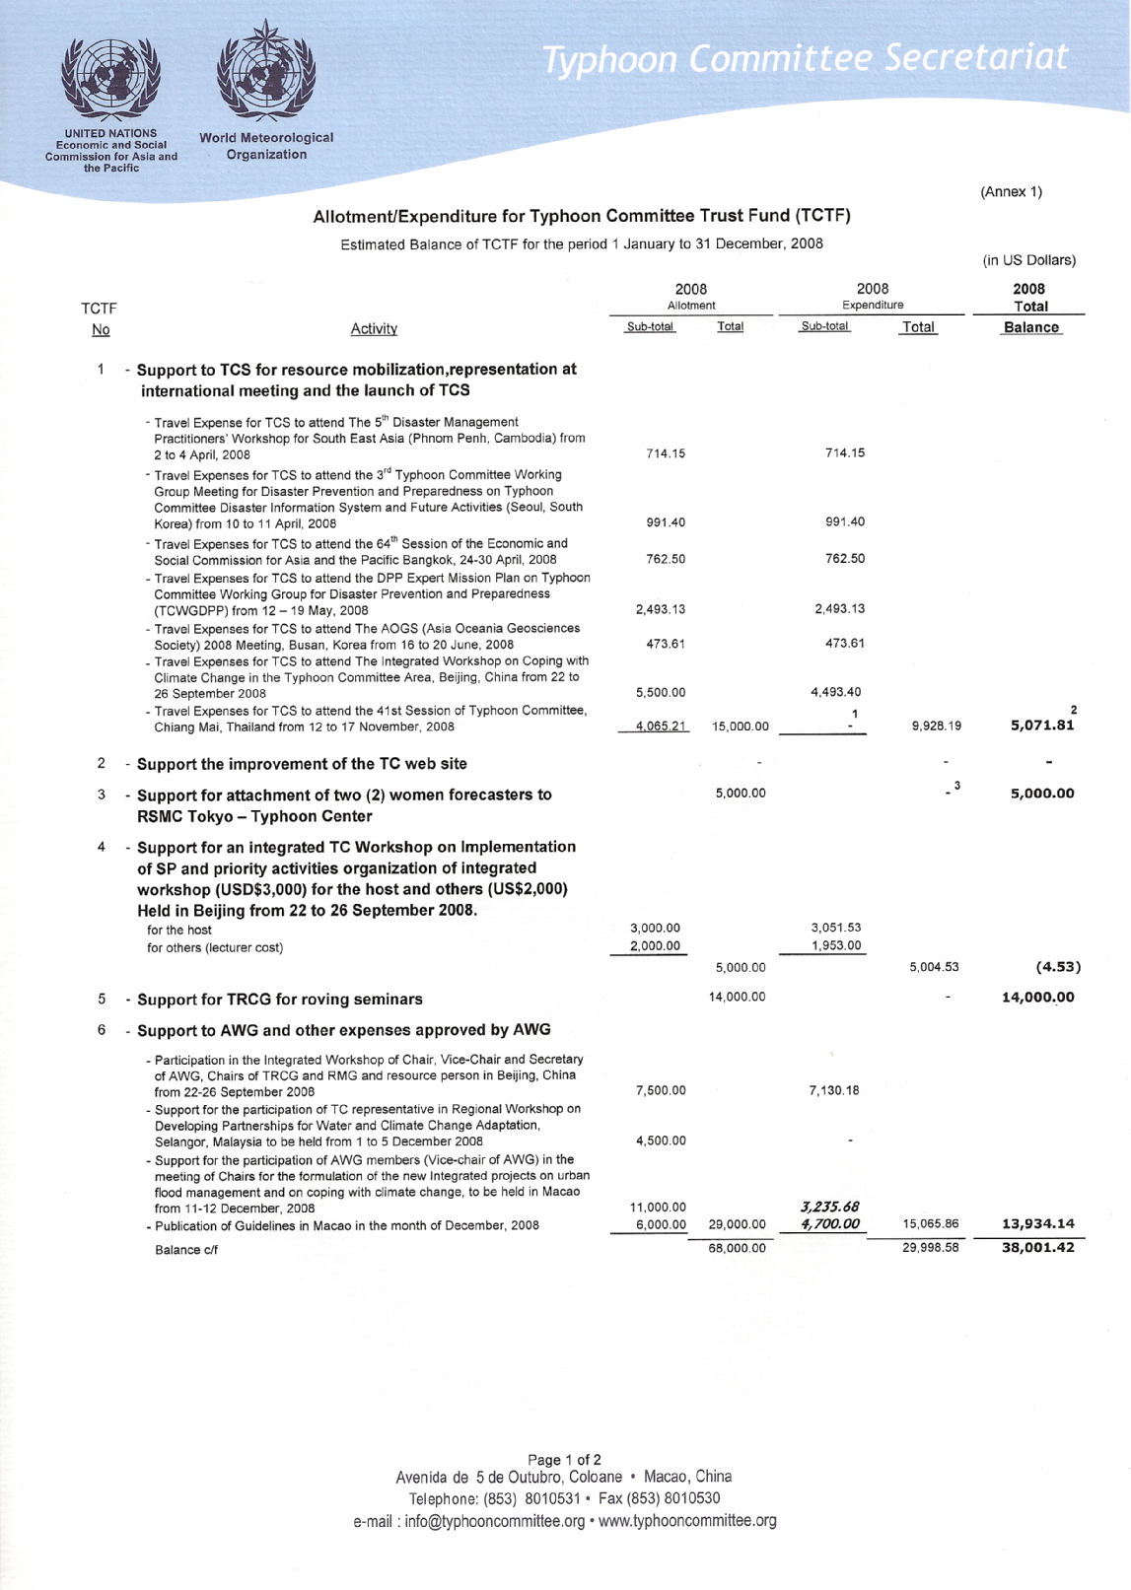

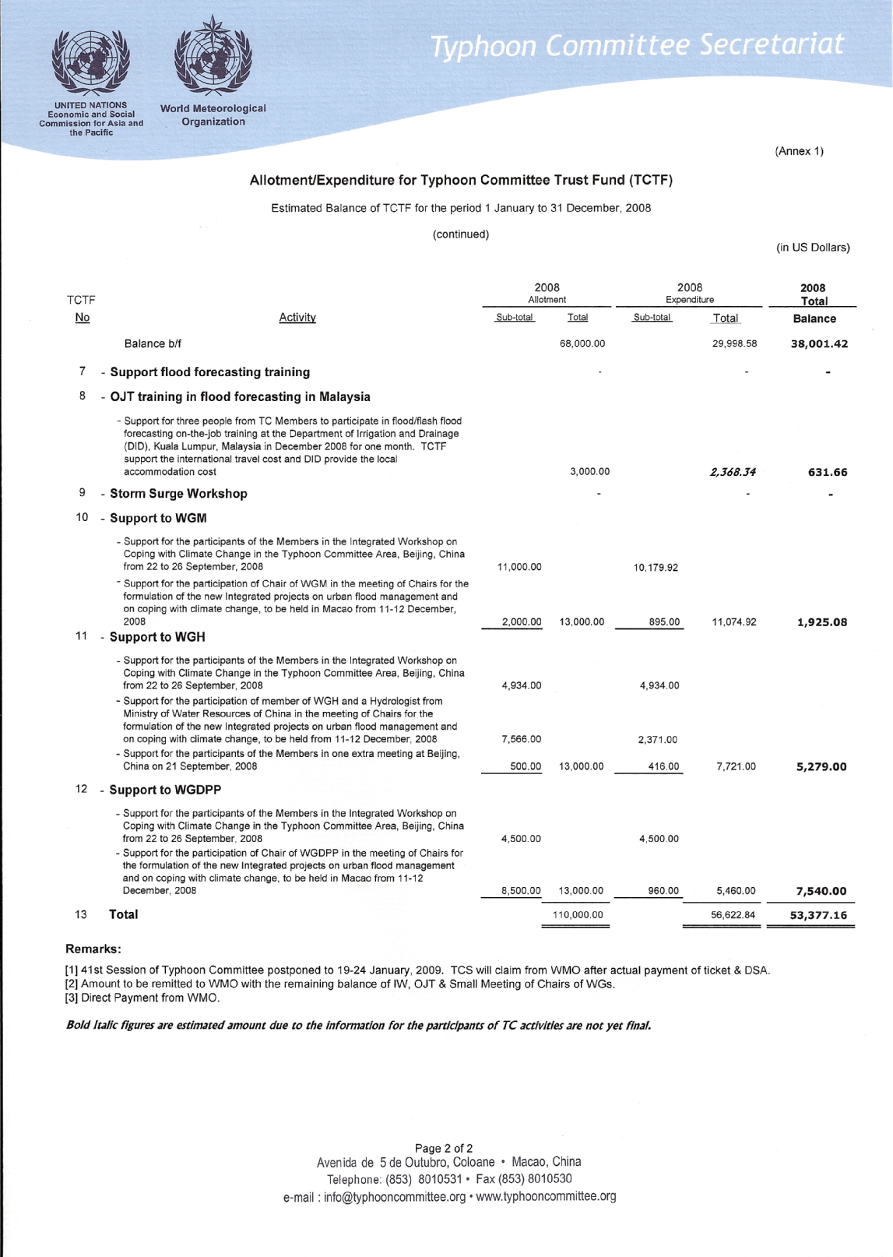

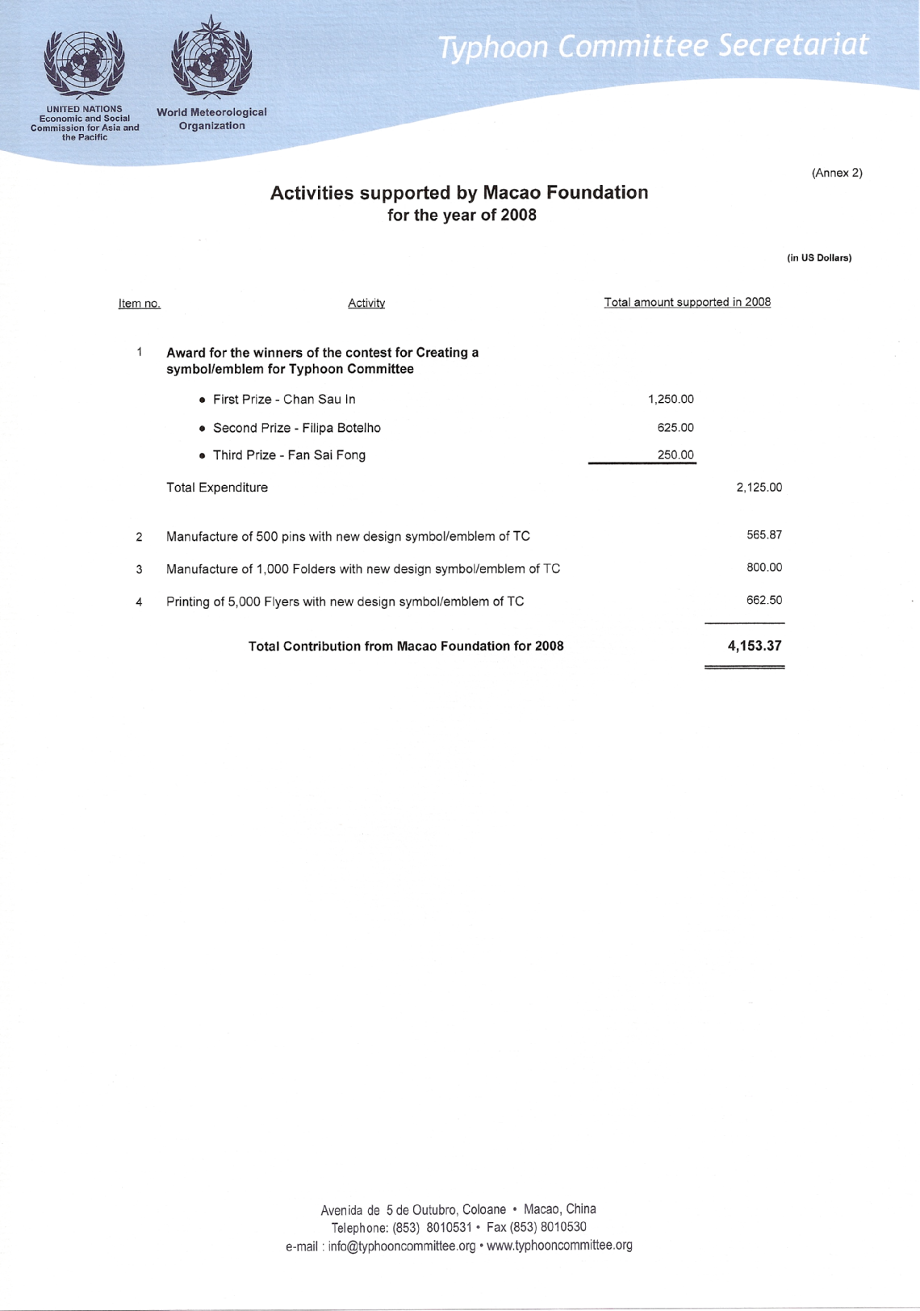

Annex 3

SUMMARY REPORT

Integrated Workshop on Coping with Climate Change in the Typhoon Committee Area

(Submitted by Typhoon Committee Secretariat)

Proposed Agenda Item 5.7

__________________________________________________________

Summary and Purpose of Document:

This document summarized the TC Integrated Workshop on Coping with Climate Change in the Typhoon Committee Area held in Beijing, China from 22 to 26 September 2008.

__________________________________________________________

Annex 3
SUMMARY REPORT

INTEGRATED WORKSHOP ON COPING WITH CLIMATE CHANGE IN THE TYPHOON COMMITTEE AREA

BEIJING, CHINA
22 TO 26 SEPTEMBER, 2008

- Introduction

The ESCAP/WMO Typhoon Committee at its 40th Session, held in Macao, China from 21 to 26 November 2007, decided to convene an Integrated Workshop on Coping with Climate Change in the Typhoon Committee Area. The Typhoon Committee also called on its Members in cooperation with the Typhoon Committee Secretariat (TCS), the United Nations Economic and Social Commission for Asia and the Pacific (UNESCAP) and the World Meteorological Organization (WMO) to assist in the organization of the Workshop. In response to this request, the Ministry of Water Resources of China and the China Meteorological Administration agreed to host the Integrated Workshop in cooperation with UNESCAP, TCS, WMO, the Ministry of Construction and Transportation of Republic of Korea (MOCT) together with the Korea Institute of Construction Technology (KICT) and the Korea Water Corporation (K-Water); and the Ministry of Land, Infrastructure and Transport of Japan (MLIT) together with the Infrastructure Development Institute – Japan (IDI) and the National Institute for Land and Infrastructure Management (NILIM).
The Workshop was held in Beijing, China from 22 to 26 September 2008 which has more than 80 participants.

- Background and objectives

The Workshop is aimed to achieve the following objectives:
1) To exchange information on priorities and key areas related to assessment and mitigation of possible social-economic impacts of climate change so as to ensure achievement of the strategic goals of the Strategic Plan of the Typhoon Committee;
2) To review progress in the implementation of the programme of work of all the Working Groups endorsed by the Committee at the 40th Session, especially Working Group on Meteorology (WGM), Working Group on Hydrology (WGH), Working Group on Disaster Prevention and Preparedness (WGDPP), Training and Research Coordination Group (TRCG), Resource Mobilization Group (TCRMG) and Advisory Working Group (AWG) in relation to the Committee’s strategic goals and expected higher uncertainties that may be resulted from possible impacts of the climate change.
3) To consolidate achievements of priority projects of all the Working Groups, especially those operational projects of WGH: namely (i) the development of flood hazard maps, (ii) the establishment of flash flood and sediment disaster forecasting and warnings systems, (iii) Evaluation and Improvement of Operational Flood Forecasting, and (iv) Development of Guidelines for Reservoir Operations in Relation to Flood Forecasting;
4) To identify priority and strategic needs of the TC Members in promoting an integrated multi-hazard early warning system for the Typhoon Committee Area so as to formulate a common strategy for the establishment of a better operational plan for the Committee as a basis to guide the annual budgeting process;
5) To identify priority areas for better enhancement of visibility of the Committee in response to the increasing interest on climate change; and
6) To develop policy recommendations on cooperation for adaptation to climate change in the Typhoon Committee Area, with special emphasis on possible common guidelines for adaptation planning.

- Outcome of the Workshop

During the Integrated Workshop, 7 invited experts on Climate Change presented their research activities on Climate Chang adaptation in water resources management and typhoon-related disaster reduction on 22nd September; 3 working groups, WHM, WGH and WGDPP reviewed and discussed the priority activities in 2008 and beyond for inclusion in the Strategic Plan and Annual Operating Plan with special emphasis on those relevant to coping with the climate change; AWG had working group meeting to discuss and make decision for Committee’s issues on 26th September; WGH held an extra planning meeting to make preliminary discussions on 21st September 2008, with about 20 participants.
The main outcomes of the workshop are summarized as below:
  - Working Group of Meteorology (WGM)
- Activities in 2008
- Typhoon Information Processing Systems (TIPS)
TIPS displays NWP tracks and the ensemble TC track. Almost all Members have developed their own system.
- Improvement of tropical cyclone forecasting skill of TC Members
T-PARC (THORPEX Pacific Asian Regional Campaign) is in operation as from July 2008 aiming to explore the effectiveness of a interactive forecasting system to improve tropical cyclone track forecasts.
- Special targeting observations for typhoons
- NWP impact experiment
- Improvement of communication system in the TC area
- Tropical cyclone classifications
- Assessment of frequency and intensity change of TC
- Reconstruction of typhoon affecting East China (1450-1949) based on historical documents
- Vulnerability assessment of water resources in a changing climate
- Activities to cope with climate change and typhoon
- Promotion of discussions among forecasters of TC Members during the approach of tropical cyclones
- Warning information dissemination
- Flood forecasting in urban areas
- New Priority Project and Activities in TC-Strategic Plan
- Assessment of frequency and intensity change of tropical cyclones
- Development of typhoon information processing system (TIPS)
- Improvement of warning services for urban areas (coastal areas) -- storm surge
- Priority Activities and Annual Operational Plan in 2009
- Assessment of frequency and intensity change of tropical cyclones
- To make a simple collective report on frequency and intensity change of tropical cyclones at 41st session (Tong Tin Ngai, Macao)
- To form an expert team at 41st session. (Recommended members: Jim, WJ Lee, CMA, MRI/JMA, HKO)
- To form a critical assessment and make suggestions / interpretation for users at TC 42nd session
- Development of typhoon information processing system (TIPS)
- To hold a workshop on TIPS (jointly with EPS) in Mid April of 2009 / late Feb 0f 2010 in ROK
- Improvement of warning services for urban areas (coastal areas)
- To hold a workshop jointly with WGH and WDPP
- To promote the application of storm surge model
- Improvement of tropical cyclone forecasting skill of TC Members
- To report the information about T-PARC to TC at 41st session (evaluation of the impact of the T-PARC special observation on typhoons)
- To improve the plan for SC
- Improvement of communication system in the TC area
- To upgrade the communication system in Members (prepared for WMO information system)
- Upgrade the VSAT system in five countries (China)
- Migration from A/N to BUFR (deadline: 2010) (ROK offered to provide software support)
- Improvement of tropical cyclone classifications
- Do not change regional common standard
- Each member establishes extra categories as necessary
- No plan for future work
- Promotion of discussions among forecasters of TC Members during the approach of tropical cyclones
- To set up an email list, consisting of forecasters of TC members
- Coordinator: (CMA)
- Improvement of warning information dissemination
- A roving seminar on forecast techniques, warning dissemination and media skills to be held in late 2009 in Hongkong/Nanjing
  - Working Group of Hydrology (WGH)
- Relevance of WGH activities to Climate Change
- Climate Change will most affect water regime. Water is the center of adaptation to Climate Change.
- WGH activities are all related to dealing with water regime in a proper way for the better quality of life of people in TC members.
- WGH participants commonly shared the recognition that past and ongoing activities under WGH are all useful for coping with Climate Change, while eagerly seeking for a new possibility of more integrated and cross-cutting projects to be tackled for better adaptation to Climate Change.
- Ongoing Projects related to WGH
- Projects to be finalized within 2008
- Development of guidelines for the reservoir operation in relation flood forecasting, led by the Republic of Korea.
- Decision Support System for Flood Forecasting System Operation & Planning (DSS-FOP), led by the Republic of Korea.
- Project on operational flood forecasting systems and its application (OFFSIA), led by China.
- Project on the establishment of community-based flood forecasting & warning system (CBFFWS), led by Philippines.
- 2nd On-the-job Training course on Flood Forecasting between TC members to be held in Malaysia.
- Guidelines to be published wit in 2008
  - Guideline for Reservoir Operation in relation to Flood Forecasting
  - General Guideline for Setting-up A Community-based Flood Forecasting and Warning System (CBFFWS)
- Projects to be finalized in 2009
  - Flood Hazard Mapping Project led by Japan.
  - Project on debris flow and landslides warning system led by Japan.
- Projects to be continued beyond 2009
  - On-the-job Training on Flood Forecasting between TC members led by Malaysia.
- New projects related to WGH
  - Project on Urban Flood Management in TC region, proposed by China.
  - Project on Assessment System of Socio-economic Impacts of Water-related Disasters for Infrastructure, proposed by Republic of Korea.
  - Project on Hazard Mapping for Sediment-related disasters, proposed by Japan.
  - Project on the Establishment of Flood Disaster Preparedness Indices, proposed by Japan.
  - Working Group of Disaster Prevention and Preparedness (WGDPP)
- Third Workshop of WGDPP
Third workshop of WGDPP was held during 10-11 April, 2008 with 21 experts from TC, 1 expert from ESCAP, 1 expert from ISDR and 1 Expert from ADRC. The workshop agreed completing Typhoon Committee Disaster Information System (TCDIS) and WEB-GIS based TCDIS:
1) providing DMS and EWS for the TCDIS
2) preparing TCDIS Manual
3) providing input data for WEB-GIS based TCDIS
4) conducting the Expert Mission for 4 countries (Viet Nam, Lao PDR, Thailand and Philippines)
- Expert Mission
The purpose of Expert Mission is:
1) to introduce the TCDIS and WEB-GIS based TCDIS;
2) to introduce the method for data input on the both system and practice with sample data;
3) to collect disaster related information and data needed for WEB-GIS based TCDIS;
4) to identify needs and gaps of participating members in relation to the implementation of the EWS and acquisition of the necessary information to TCDIS;
5) to explore whether there is a need for public out-reach projects in relation to EWS and disaster risk reduction in the participating Members.
- Development of TCDIS
- Necessity
  - Need to establish efficient data sharing or management system of typhoon related disasters for TC member countries;
  - Need to pursue accurate, rapid, and economic system through damage prediction, damage assessment and recovery support functions.
- Final Objective
To establish disaster-related data sharing system among the member countries and in the region:
  - Phase I: Disaster Information System (DIS) was developed to support the decision-making process and early warning through database construction of GIS and various disaster information.
  - Phase II: Expansion of DIS to member countries and other organizations.
- Publication in 2008
  - Typhoon Committee Expert Mission Report (WMO/TD-No. 1448)
  - Typhoon Committee Disaster Information System Manual (WMO/TD-No. 1449)
- Publication within 2009
  - Report on UNESCAP/WMO Typhoon Committee Members Early Warning System
  - Report on UNESCAP/WMO Typhoon Committee Members Disaster Management System
  - Advisor Working Group (AWG)
- The Dr. Kintanar Award
Discussed the Rules and Procedures for “Dr. Roman L. Kintanar Award for Typhoon-related Disaster Mitigation” and it was decided that the Dr. Kintanar Award should be given to organizations, not to individuals.
- Publications of WFH
Decided to publish above-mentioned two Guidelines of WGH
- Inter-Working Group Chairs meeting
Decided to hold inter- working group Chairs meeting within 2008 to discuss how we can explore the collaboration on Urban Flood issues in the climate change context, together with discussion on other possible collaboration.
- Amendment of the LoA
Chairs of WGs were requested to give priorities and amounts to TCS for the amendment of the LoA referred to Allocation for small inter-WG meeting on “Urban Flood issues in the climate change context”, Allocation for publication of Guidelines
- Emblem, brochure and booklet
Suggestions were made for Emblem, brochure and booklet.
- Integrated Workshop 2009
It was decided to hold the 4th IWS in Cebu, Philippines in October 2009 (back to back with the 4th Southeast Asia Water Forum).
- Projects profile format proposal
Projects should be formulated according to a model (e.g., the one presented by Ti)
The project (Management of Floods in Urbain Areas) could be presented to donors by TCS and ICHARM
- Roving Seminars
R.S. should be more enlarged to include Hydrology and DPP, besides Meteorology.
For instance, the next R.S. should involve media training linked to Met, Hyd, DPP and Climate Change. Let’s the Members decide.
- TCS Website
Docs for the Session shall be posted in the TCS Website;
The Reports of the Sessions should also be posted in the TC Website

